**Volume II – Factor I – Technical Approach**

**Stealth Solutions, Inc.**

**Response**

**to**

**Internal Revenue Service (IRS)**

**IT Accessibility and Section 508 Compliance Service**

**RFQ No: 2031ZB-24-Q-00006 A00002**

**August 15, 2024**

**Submitted By:**

Stealth Solutions, Inc.

**SBA Certified 8(a) Program Participant**

**SAM UEI: RCMZNAHAZ7D9**

**GSA STARS III: 47QTCB21D0018**

46191 Westlake Dr. #112

Sterling, VA 20165

Rahul Sundrani

[Rahul.Sundrani@Stealth-US.com](mailto:Rahul.Sundrani@Stealth-US.com)

571-230-5642

Table of Contents

1 Technical Approach 2

2 Understanding of Requirements 2

3 Team Stealth Capabilities Correlating to the Performance Work Statement (PWS) Objectives and Scope Areas 3

4 Team Stealth Execution Approach 4

4.1 Accessibility Assessment and Remediation (Addresses RFP/PWS Section 2.1) 5

4.2 Education and Awareness Approach (Addresses RFP/PWS Section 2.2) 12

4.3 Strategic Planning for Enhanced Compliance (Addresses RFP/PWS Section 2.3) 13

4.4 Workforce Diversity and Inclusive Technology (Addresses RFP/PWS Section 2.4) 14

5 Conclusion/Summary 15

6 Key Personnel Resumes 16

6.1 Contractor Project Manager – Priya Jain 16

6.2 IT Subject Matter Expert – Meena Patel 19

6.3 Accessibility Testing Applications Engineer – Kyle Paciello 22

7 Commitment Letters of Key Personnel 25

7.1 Priya Jain 25

7.2 Meena Patel 26

7.3 Kyle Paciello 27

# Technical Approach

Team Stealth is pleased to explain our technical approach to this project and to demonstrate our ability to successfully perform and comply with the services outlined in the PWS. We have a clear understanding of the government’s needs as our team is very experienced in delivering the services requested and we provide the government with our explained capabilities and methodology to execute and deliver on your specific needs.

We have also provided details on our named key personnel that will unequivocally demonstrate the breadth and depth of our team’s experience, qualifications, and certifications to perform against the government’s requirements.

# Understanding of Requirements

The Bureau of Engraving and Printing (BEP) is seeking expertise to ensure compliance with Executive Order 14035, signed by President Biden in June 2021, which mandates Section 508 compliance for all federal agency public-facing websites and digital content. This directive aims to enhance accessibility for individuals with disabilities, ensuring that websites, documents, and multimedia content are fully accessible.

To achieve this, BEP requires a comprehensive assessment of existing digital assets, including internal and external websites, to identify and rectify any accessibility issues. The following are the key requirements that must be met to achieve success:

1. **Detailed Compliance Assessment:** Evaluate current materials for Section 508 compliance, prioritize issues, and develop targeted remediation plans.
2. **Process Development:** Establish protocols to ensure all new content is accessible before publication.
3. **Stakeholder Education:** Conduct training sessions for content creators and web managers on best practices for creating accessible digital content.
4. **Strategic Guidance**: Provide strategic planning support to integrate accessibility into BEP’s long-term technology initiatives, ensuring ongoing compliance.
5. **Technology Support**: Recommend and promote the use of accessibility tools and assistive technologies to foster an independent content creation environment that does not hinder individuals with disabilities.

Team Stealth, led by Stealth Solutions and supported by Deque Systems, is ideally positioned to address these requirements. Stealth Solutions brings a wealth of experience in technology deployment and digital content management, including a proven track record of maintaining Section 508 compliance in government projects. Our partner, Deque Systems, is a recognized leader in digital accessibility, equipped with the largest team of IAAP-certified professionals and Trusted Testers who specialize in advanced accessibility testing and document remediation. Together, we offer a deep understanding of federal accessibility standards and a commitment to delivering technology solutions that ensure inclusive, accessible digital environments.

Our combined expertise makes Team Stealth the ideal partner to help BEP achieve and sustain Section 508 compliance, enhancing accessibility across all digital platforms.

# Team Stealth Capabilities Correlating to the Performance Work Statement (PWS) Objectives and Scope Areas

Team Stealth, combining the strengths of Stealth Solutions and Deque Systems, presents a unified approach tailored to meet the objectives specified in the BEP’s Performance Work Statement (PWS). Our collaboration draws upon Deque’s two decades of leadership in digital accessibility and Stealth’s expertise in technology deployment and project management.

Figure 1: Team Stealth Comprehensive Framework: Services, Tools, and Training Across the Product Lifecycle.

**Industry Leadership and Contributions:**

* **Strategic Leadership:** Glenda Simms, Deque’s Chief Information Accessibility Officer, is a recognized figure in the digital accessibility community. Her efforts extend across governmental bodies and educational institutions to advance web accessibility standards globally.
* **Global Standards Development:** As an active member of the World Wide Web Consortium (W3C), Deque contributes both financially and intellectually. Melanie Philipp, holding a seat on the W3C Advisory Council, plays a crucial role in the development of inclusive web protocols.

**Team Stealth’s Aligned Expertise with BEP Objectives:**

* **Comprehensive Service Delivery:** Our service team applies globally recognized testing methodologies to ensure robust digital accessibility across all platforms.
* **Document Center of Excellence:** Our focus on efficient and effective document remediation guarantees comprehensive compliance with current accessibility standards.
* **Web and Applications Testing:** We conduct extensive assessments of web properties through automated, manual, and functional testing, ensuring compliance with the highest accessibility standards.
* **Educational Outreach and Training:** We offer in-depth training sessions that enhance the adoption of best practices in digital accessibility, facilitated by our collective expertise.
* **Innovative Product Solutions:** We develop advanced tools for automated testing of web and mobile applications, ensuring continuous accessibility evaluations and seamless integration into existing tech stacks.
* **Strategic Consulting for Sustained Impact:** Our team of strategic consultants and program management professionals guides organizations to develop and refine effective, sustainable accessibility strategies, aligning closely with BEP’s mission to foster an inclusive digital environment.

With Stealth Solutions bringing extensive experience in implementing and maintaining Section 508 compliant solutions and Deque’s leadership in digital accessibility, Team Stealth is ideally positioned to support BEP in achieving and sustaining compliance, setting a standard for accessibility within the federal space.

# Team Stealth Execution Approach

Team Stealth implements Section 508 compliance projects using established project steps that ensure we and our clients achieve the outlined deliverables. Detailed below is our execution approach for each area specified in the PWS:

1. Accessibility Assessment and Remediation
2. Education and Awareness Approach
3. Strategic Planning for Enhanced Compliance
4. Workforce Diversity and Inclusive Technology

Each step of our approach and the associated deliverables are thoroughly described in the following sections.

## Accessibility Assessment and Remediation (Addresses RFP/PWS Section 2.1)

Team Stealth will conduct a thorough and detailed initial assessment of Section 508 compliance across all information and communication technology (ICT) materials published on the Bureau of Engraving and Printing’s internal and external websites. This initial phase will utilize our proprietary axe Monitor tool for a one-time automated scan of designated web properties.

**Detailed Assessment Process:**

1. **One-Time Automated Scanning:** The initial step in our compliance assessment involves a one-time deployment of the axe Monitor tool. This tool will efficiently scan the web pages, identifying accessibility issues and assisting in the creation of a comprehensive inventory of all documents and multimedia content, including PDFs and video files.
2. **Document and Video Inventory:** As part of the one-time scan, the tool will parse through PDF documents to detect accessibility issues that can be automatically identified and catalog all video files on the sites to determine the requirements for transcription services to ensure multimedia content complies with accessibility standards.
3. **Dashboard and Reporting:** Following the scan, each tested web property will be represented on an interactive dashboard. This dashboard will display an overall compliance score for each site and include detailed drill-down capabilities, allowing for an in-depth review of specific issues detected during the scan. This functionality is essential for prioritizing remediation efforts and monitoring progress toward full compliance.
4. **Guidance for Remediation:** The issues identified through this one-time automated testing will be detailed in a comprehensive report, which will also provide actionable guidance for content providers and developers. This guidance will offer practical, “real-world” solutions for addressing and rectifying the detected accessibility barriers and facilitating effective compliance enhancement initiatives.

Figure 2: Dashboards with an overall compliance score and detailed drill-down of issues and remediation

The US Treasury and the Defense Logistics Agency regularly use the axe Monitor tool to scan their websites, relying on its comprehensive and accurate testing capabilities to enhance their digital accessibility initiatives and bolster Section 508 compliance. Additionally, the US Treasury incorporates PDF testing during their site scans.

1. **Manual Testing**: Team Stealth utilizes automated testing as the initial step to quickly gauge compliance with the Revised Section 508 standards for documents and websites. This method identifies approximately 32% of document compliance issues and 56% of web compliance issues through automation alone. However, to fully assess and address compliance, manual testing is essential.
   * **Web Manual Testing**: This involves a detailed examination of a representative sample of web pages. The scope of manual testing depends on various factors, including the number of templates used, the identification of core components, and key user journeys. Team Stealth will evaluate a limited set (~120) of unique pages across all sites, conducting both manual and functional tests on these pages. The results will be compiled into comprehensive reports for each site, detailing findings from automated, manual, and functional tests based on the Section 508 refresh standards. These reports will be accessible to all relevant bureau personnel, particularly web teams tasked with remediation, and include access to a knowledge base for guidance on resolving detected issues.
   * **Document Manual Testing**: Unlike web testing, document testing allows for simultaneous testing and remediation, thus optimizing both time and cost efficiency. Following the initial inventory and automated testing phase, documents will be prioritized for immediate testing and remediation. This integrated approach ensures that document accessibility aligns with web accessibility standards, enhancing overall compliance efforts.

**Remediation Plan for Web and Documents**

Team Stealth’s Remediation Plan for Web and Document Accessibility offers a comprehensive and structured approach to ensure compliance with Revised Section 508 standards. This plan leverages both automated and manual testing methods to deliver actionable insights and prioritize remediation tasks.

1. **Web Accessibility Remediation:** The assessments produce detailed reports which form the basis for a tailored remediation strategy, offering:
   * **Comprehensive Compliance Review**: A precise evaluation of the current compliance status for each property.
   * **Remediation Guidance**: Specific recommendations for addressing deficiencies based on the selected standards, facilitating the development and implementation of an effective remediation plan.

**Components of the Remediation Process**:

Together, these will enable the creation and execution of an effective remediation plan. The **Remediation Plan** will entail:

* + **Executive Summary**:Team Stealth crafts a detailed written summary of the testing results, which includes:
    - The standards applied for assessment.
    - An explanation of the methodologies used to determine the results.
    - Descriptions of issue severity and the count of issues categorized by severity.
    - The business impacts of the issues are based on their severity.
    - A detailed remediation prioritization guide.
  + **Detail Report:** A comprehensive digital report accessible to designated stakeholders includes:
    - Summary of findings.
    - Clearly defined and prioritized issues.
    - Detailed descriptions of each issue, pinpointing where it exists within the code.
    - Direct links to the relevant success criteria.
    - Guidelines on how to manage, group, and rectify issues to align with organizational goals and development practices.
  + **Results Review Sessions:** A strategic meeting with all relevant BEP personnel to discuss the assessment findings and prioritize remediation efforts. The following chart outlines potential severity levels, aiding in the prioritization of remediation tasks based on their impact on the user experience and business operations:

|  |  |
| --- | --- |
| Impact | Description |
| Blocker | Prevents some users with disabilities from using your core content - period. |
| Critical | Prevents some users with disabilities from accessing certain parts of your content, potentially rendering it unusable. |
| Serious | Presents serious barriers for some users with disabilities and will partially prevent them from using portions of your content. |
| Moderate | Presents some barriers for users with disabilities that will reduce their overall experience with your content. |
| Minor | Causes some nuisance but does not present barriers for users with disabilities. |

Figure 5: Impact Severity Level and Description

**Example of Support for DLA**: Team Stealth also provides specialized consulting and manual testing support to the **Defense Logistics Agency (DLA)**, tailoring our services to meet their specific needs for ongoing digital accessibility compliance in line with Section 508 standards.

1. **Document Remediation**

Team Stealth’s Document Remediation Plan is meticulously designed to ensure compliance with Revised Section 508 standards, following a structured approach based on the outcomes of automated testing. The plan meticulously outlines the process for prioritizing documents, scheduling compliance updates, and detailing the necessary efforts for successful remediation.

**Initial Steps and Strategy:**

* + **Comprehensive Review**: The remediation process begins with a detailed examination of document branding and design. Any instances of non-compliance identified during this review will be communicated to the relevant marketing and design teams. This feedback loop is crucial for integrating necessary adjustments and provides hands-on training to enhance understanding and implementation of accessible document practices.
  + **Effort and Duration**: The time required for document remediation is closely linked to their complexity and volume. Based on the shared two-year document history and considering the volume of documents categorized as Low, Medium, High, and Very High, it is estimated that approximately 2,000 pages per month will require remediation. Team Stealth has systematically planned for this remediation to be an ongoing activity, carried out by our Web Content Analysts Level II. We have thoroughly assessed and are acquainted with the expected turnaround times for the various document types specified by the Bureau.

**Document Remediation Process:** As indicated above, testing and remediation of the documents will occur at that same time by a document accessibility expert. The document remediation process includes, but is not limited to:

* + **Semantic Enhancements**: Addition of semantic tags such as headings, paragraphs, and lists, ensuring they follow a logical reading order.
  + **Accessibility Features**: Enhancement of document navigability by tagging links and making them keyboard accessible.
  + **Alt Text and Metadata**: Insertion of accurate alternative text for images and structuring of data tables with properly scoped headers. The process also includes embedding fonts, setting the correct document language, and ensuring accurate metadata and document reflow order.
  + **Quality Assurance:** Team Stealth utilizes a combination of automated testing with industry-standard accessibility checkers, including Adobe Acrobat Professional and PAC 2024, alongside manual testing with assistive technologies like the NVDA screen reader. Our remediation methodology not only ensures compliance with the Revised Section 508 standards but also offers extensive coverage that aligns with the detailed Section 508 checklist, as **outlined in Attachment A**.

**Outcome and Deliverables:** The culmination of Team Stealth’s remediation efforts results in the delivery of documents that are compliant with the Revised Section 508 standards. These documents are prepared in a variety of formats—Microsoft Office 365, Adobe Acrobat Pro DC PDF, RTF, HTML, or plain text—determined by technical feasibility. Once compliant, these documents will be published on the Bureau’s Intranet and external web pages by Team Stealth, ensuring broad accessibility and adherence to required standards.

* + **Remediated Document Deliverable:** Team Stealth will deliver PDF documents compliant with the Web Content Accessibility Guidelines (WCAG) 2.1 Levels A and AA, PDF/UA, and Section 508 standards. Each document will be accompanied by a detailed compliance report, which will outline any content-specific exceptions and provide full transparency about our remediation process. An example PAC test report is provided below for reference.

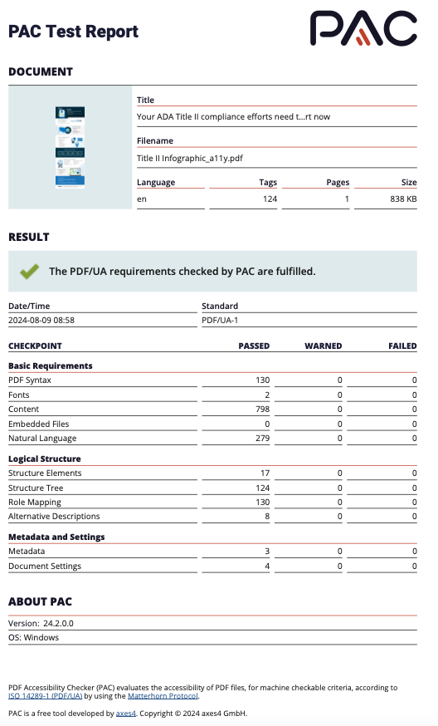

Figure 6: Team Stealth - Example of PDF Section 508 Compliance Report

**Support Example from the US Mint:** Over the past fifteen years, the US Mint has benefited from our comprehensive services. During this period, our team has conducted web and document reviews employing both automated and manual testing techniques. According to feedback provided in the US Mint’s past performance questionnaire, our reporting consistently surpasses the Treasury’s objectives for Section 508 compliance.

1. **Audio and Video Remediation (Transcription):** Our transcription process ensures 99% accuracy, meticulously capturing every word with precise timing for captions. We offer transcription outputs in formats such as TXT, DOC (Plain and Stamped), PDF, HTML, and JSON. Our services transform audio and video recordings into perfectly synchronized, accessible text formats, supporting all common caption and subtitle file types (e.g., .srt, .svb, .sub).
   * **Compliance and Standards:** Our transcription services comply with Section 508 Revised, WCAG 2.1, and DCMP captioning guidelines, ensuring adherence to best practices for tone, caption formatting, grammar, and line breaks. We maintain rigorous standards covering a wide range of transcription elements, including paragraphing, handling of technical terms, word synchronization, and the accurate representation of accents, overlapping speech, and various textual formats like numbers, dates, and acronyms.
   * **Deliverables:** Transcriptions are provided specifically in English and are completed and returned in the requested formats, accommodating custom requirements as needed. Each transcription adheres to the BEP’s specified turnaround times, ensuring timely and reliable delivery.

## Education and Awareness Approach (Addresses RFP/PWS Section 2.2)

Team Stealth has meticulously crafted training materials and curriculums tailored to the specific roles and experiences of learners, further delineating the content by applicable technologies. All training materials will be modified to include examples specific to the Bureau documents and Web content to provide further stickiness in terms of knowledge transfer. These training sessions are designed to be delivered either virtually or in person, each led by a live instructor. We find that a hybrid approach, combining live sessions with supplementary video recordings, provides the most comprehensive training coverage for all types of learners. Below is an outline of course examples to demonstrate our training competency and skills:

1. **Document Accessibility Training:** Topics include creation, remediation, and testing of Office documents (Word, PowerPoint, Excel), Adobe InDesign, and Adobe PDFs, incorporating Bureau-specific documents to enhance relevance and knowledge retention.Document accessibility testing methodology, following our proven methodology. The curriculum includes hands-on workshops and exercises, adapting to the unique document requirements of the Bureau.
2. **Web Accessibility Bootcamp**:This immersive training introduces participants to digital accessibility barriers, tools, and best practices, fostering a shared language and understanding of accessibility. The audience includes developers, designers, content creators, and managers, utilizing Bureau-specific sites and documents for practical examples. Key topics covered include the use of color, screen readers, keyboard navigation, image communication, document structure, and ARIA roles. A training plan will be developed based on Section 508 Compliance Assessment and Remediation findings. This plan will be tailored to address the specific issues identified in non-compliant documents and web pages, as revealed by our automated scans, and will consider the training needs of the identified personnel.
3. **Accessibility Fundamentals for Everyone**: Through real-world scenarios and personas, this course explores how disabilities affect digital interactions, providing participants with actionable insights for immediate application. Topics include understanding the business case for digital inclusion, evaluating web accessibility, and identifying roles in enhancing digital accessibility.
4. **Accessibility Awareness for Everyone**: This course raises awareness about web accessibility, exploring its impact through assistive technologies and real-life stories from Team Stealth team members. It includes a live demonstration of assistive technology, discussions on various disabilities, and an engaging Q&A session to deepen understanding and empathy among participants.

**Training Deliverables and Implementation:**

1. **Annual Training Plan**: Includes multiple virtual sessions such as Document Accessibility, Accessibility Bootcamp, and Accessibility Awareness, each tailored to specific topics and designed for optimal participant engagement.
2. **Recordings and Resources**: All sessions will be recorded, with the Bureau having access to these resources for one year, ensuring ongoing learning and reference.
3. **Project Management**: Our Project Manager will coordinate all aspects of training delivery, from scheduling to material distribution and facilitation.

These training programs are crafted to align with the outcomes of the Section 508 Compliance Assessment and Remediation, ensuring that all training is relevant, timely, and effectively meets the needs of the Bureau. Through this robust training approach, Team Stealth not only aims to educate but also to empower participants to champion accessibility within their professional spheres.

## Strategic Planning for Enhanced Compliance (Addresses RFP/PWS Section 2.3)

A strategic consultant from Team Stealth will develop a Digital Accessibility Transformation Playbook tailored to the unique structure, processes, tools, and technologies of the Bureau. This playbook is crafted using our proven methodology and aims to significantly elevate the Bureau’s accessibility maturity in the near term.

**Playbook Overview:**

* The playbook offers comprehensive recommendations for enhancing the Bureau’s accessibility initiatives. It covers essential areas such as Development, Testing, Training, Governance, Policy, Legal, Fiscal, Procurement, Communications, and Support.
* It details the current state, desired outcomes, and specific actionable steps to advance the Bureau’s accessibility goals. Additionally, it includes essential jump-start materials like role-based training curricula, policy language, and educational guides tailored to the Bureau’s needs.
* The Digital Accessibility Transformation Index included in the playbook serves as a baseline for measuring maturity and tracking progress over time.

**Process:**

* **Discover**: Conduct interviews with stakeholders and review current processes, policies, and metrics to identify gaps and document opportunities for improvement.
* **Deliver and Decide**: Present findings, solidify immediate action plans and build an executive overview with recommendations for both near-term and long-term execution.
* **Execute**: Collaborate with the Bureau to implement the agreed-upon steps, incorporating necessary process changes, training, and tools.
* **Review**: Monitor progress, evaluate success against established metrics, and plan further actions as needed.

**Deliverables:**

* A bespoke, prioritized playbook that addresses the Bureau’s specific challenges and barriers, providing a clear roadmap for achieving sustained compliance.
* The playbook will be delivered iteratively, focusing on the prioritized categories in collaboration with the Bureau to ensure effective implementation.

Through this strategic approach, Team Stealth ensures that the Bureau is equipped with a detailed and actionable plan to build and maintain robust digital accessibility across the organization.

## Workforce Diversity and Inclusive Technology (Addresses RFP/PWS Section 2.4)

As part of the broader playbook initiative, Team Stealth will thoroughly analyze and enhance the design, development, and quality assurance processes within the Bureau. This comprehensive approach aims to integrate digital accessibility deeply and sustainably into daily operations across all creative and development roles.

**Enhancements and Guidance:**

* **Design Systems Analysis**: We will evaluate existing design systems, practices, and tools. Where necessary, we will recommend tools that seamlessly integrate into daily routines, enhancing accessibility without disrupting the design process.
* **Development Technology Stack Review**: Our team will document the current technology stacks and accessibility testing tools in use at the Bureau. We will suggest tools that not only fit within existing technologies but also enhance the ability to identify and rectify accessibility issues early in the development phase.
* **Procurement Process Integration**: We will provide strategic guidance on incorporating accessibility compliance into the Bureau’s procurement processes, ensuring that all procured solutions meet Section 508 standards.
* **Awareness and Training**: We will outline necessary awareness training to motivate developers and designers to adopt accessible coding practices, fostering an environment of inclusivity.

**Deliverables:**

* The playbook will be meticulously refined to ensure comprehensive coverage of inclusive design and technology strategies. This will include clear guidelines and processes designed to support and promote these initiatives effectively within the Bureau.

By embedding these strategies into the playbook, Team Stealth ensures that the Bureau’s commitment to diversity and inclusion is actionable, measurable, and aligned with best practices in digital accessibility.

# Conclusion/Summary

Team Stealth’s comprehensive approach described above underscores our commitment and capability to meet the stringent requirements set forth by the Bureau of Engraving and Printing (BEP) for achieving enhanced digital accessibility across all platforms. Our unique combination of advanced technology integration, rigorous methodology, and strategic foresight positions us as the ideal partner for BEP.

Our approach encompasses a detailed initial assessment using our automation scanning, followed by systematic manual testing to ensure comprehensive compliance with Section 508 standards. We have demonstrated our capacity to evaluate and address accessibility at every stage of the content development lifecycle, from design to deployment.

Moreover, our strategic planning includes the creation of a Digital Accessibility Transformation Playbook that not only assesses current capabilities but also sets a clear roadmap for future enhancements. This playbook is part of a broader commitment to integrating accessibility into every facet of BEP’s operations, ensuring that accessibility considerations are woven into the fabric of organizational processes.

In addition to our technical and strategic capabilities, Team Stealth brings a depth of experience and a proven track record from past engagements with federal entities such as the US Treasury and the Defense Logistics Agency. Our ability to tailor our solutions to meet specific organizational needs—and our focus on training and capacity building—ensures that BEP’s staff are well-equipped to sustain these accessibility standards over the long term.

By choosing Team Stealth, BEP will leverage a partner known for its dedication to excellence and its proactive approach to accessibility challenges. We are not just fulfilling a contract; we are setting a standard and leading the way in creating an inclusive digital environment that accommodates all users, irrespective of their abilities.

# Key Personnel Resumes

## Contractor Project Manager – Priya Jain

Experience overview

Accomplished result-driven Delivery Manager and Agilist with hands-on experience in leading the delivery of IT solutions across all the phases of software development life cycle. Bringing progressive professional experience in software development, project leadership and client engagement. Known for coaching, mentoring and leading project teams with a focus on delivering strong business results and adopting Agile best practices. Strategic Agile mentor translating vision into actionable plans and building high-performing Agile teams to continuously deliver value to the stakeholders. Proficient in resolving business issues and serving as a liaison between stakeholders and cross-cultural teams while working within strict deadlines. Self-driven individual with exceptional ability to quickly master new concepts, a collaborator with excellent communication and interpersonal skills.

Education

Master of Business Administration (M.B.A.), NRIBM, Gujarat University, India

Technical Domain AnD FUNCTIONAL Expertise

Tools/Platform: Team Foundation Server (TFS) | Atlassian Suite (Confluence, Jira) | Target Process | Azure DevOps | Microsoft Dynamics | Tableau | Salesforce | Jenkins | GitHub | CI/CD | Trello | Visio | Test Director | MS Office | Quick Test Pro | Test Director | Public Trust Clearance

Agile and Waterfall Project Management | Team and Resource Development | Process Analysis |

Software Development Lifecycle (SDLC) | SAFe, Kanban | Quality Management | Risk/Contingency Management | Team Engagement | Budgeting and Forecasting | Stakeholder Collaboration| Coaching and Mentoring | Cross-functional Team Leadership | Process Improvement and PMO Support

certifications and Technology–Specific training

Certified Scrum Master (CSM)|ISTQB/ASTQB Foundation Level Certified |SAFe 5 Advanced Scrum Master (SAFe SASM)|Professional in Agile Test Automation (ICP-ATA) |CMMI Dev trained | Certified Professional in Agile Testing (ICP - TST)|Pursing PMP Certification

Project Experience

MERP Systems Inc, Herndon VA December 2023 – April 2024

*Senior Project Manager / Program Manager*

Led a project utilizing Microsoft Dynamics for federal clients aimed at facilitating the modernization of a legacy web-based national reporting system used by FNS program administrators for data submission.

Key responsibilities include:

* Worked closely with stakeholders to gather requirements, define project scope, and establish project objectives, ensuring alignment with client expectations and organizational goals.
* Effectively coached and implemented Agile methodologies across globally distributed cross-functional teams, resulting in improved project delivery efficiency and increased stakeholder satisfaction.
* Created thorough project plans encompassing scope, schedule, resource allocation, RAID logs, and budget.
* Monitored project progress, identified risks and implemented mitigation strategies to ensure successful project delivery. Designed and maintained comprehensive metrics and reports shared with client and internal leadership to track progress.

American Family Insurance, Madison WI April 2022 – October 2023

*Program Manager / Agile Delivery Manager*

Led Master Data Management (MDM) to successfully deliver the business requirements on time and within budget. Coached and mentored 16 Scrum Masters, 12 Product Owners, multiple Leaders, and 12 Teams to execution and maturity of frameworks, roles, and meaningful metrics for Digital Services Platform (DSP) – Acquisition and Retention.

Key responsibilities include:

* Developed comprehensive project plans, including scope, schedule, resource allocation, RAID logs and budget.
* Monitored project progress, managed project risks and coordinated with stakeholders to define project objectives to ensure successful delivery.
* Facilitated project meetings and provided regular updates to stakeholders on project status. Conducted post-project reviews to identify lessons learned and areas for improvement.
* Managed internal resources and third parties/vendors for the flawless execution of projects and minimize waste while maximizing business value delivered.
* Developed reports and dashboards for monthly and quarterly updates for leadership to track critical path initiatives and ensure accountability.
* Facilitated intra and inter-team Agile events and ceremonies for multiple product and service teams.
* Increased awareness and adoption of Agile principles, values, mindset, and SAFe framework across company enterprise comprising of almost 13,000 employees.
* Completed sprint zero with 8 teams and leaders including initial Agile/Scrum training, product road mapping, story road mapping, story writing, and sizing. Created and delivered basic Agile/Scrum training to over 200 employees. Created and delivered story writing and sizing training to over 100 employees.
* Coached 6 digital sales platform teams with agile principles in outreach and opportunity evaluation processes to arise in JD Power Ranking from 6th in 2022 to 1st in 2023.
* Provided vital support in Enterprise’s transformation effort to reduce the expense-revenue ratio and meet the target of $400M by ensuring initiatives and projects adhere to budgetary constraints and schedules.

REI Systems Inc, Sterling VA February 2011 – March 2022

*Agile Delivery Manager | Project Manager*

Led the implementation of GovGrants, a grants management SaaS product built on the Salesforce platform for several State government agencies and Nonprofit organizations including Los Angeles Homeless Services Authority (LAHSA), SC Dept of Education, Washington OSPI, and National Endowment for Democracy.

Key responsibilities include:

* Directed product, engineering, and customer success teams to provide seamless product implementation experience. Managed a budget of over $10M for product implementation across the 4 projects.
* Contributed to the formulation of the project governance and stakeholder management plan by actively identifying, analyzing, comprehending stakeholder expectations and ensuring effective communication at different organization levels.
* Successfully transitioned 4 teams to the Scrum methodology, provided guidance and training to 30+ team members.
* Conducted thorough accessibility audits of web content, applications, and digital documents, identifying areas of non-compliance with WCAG standards.
* Worked closely with designers and developers to integrate accessibility into the design and development phases providing guidance to meet the WCAG requirements.

URLA & GUS Modernization, USDA September 2018 – July 2020

*Agile Delivery Manager | Sr Scrum Master*

Successfully coached and managed three cross-functional Scrum teams comprising over 40 members to modernize the existing GUS (Guaranteed Underwriting system) built on Java platform to the Salesforce Lightning platform.

Key responsibilities include:

* Supported the migration effort of the legacy integrations with external systems to the new platform using MuleSoft.
* Collaborated with stakeholders to identify and map Value Streams, ensuring alignment with organizational goals and maximizing value delivery.
* Provided hands-on coaching during Agile Release Train (ART) execution, ensuring adherence to Agile practices, facilitating PI Planning, and resolving impediments to maintain ART momentum.

NASA SBIR/STTR December 2016 – August 2018

*Project Manager*

Managed 25+ team members, overseeing a broad service portfolio, including EHB system operations, modernization, system administration, program operations, helpdesk, and outreach.

Data.gov February 2011 – November 2016

*Lead Test Engineer*

Led QA efforts for various federal projects (Data.gov, Geo.data.gov, resources.geoplatform.gov, HowTo.gov, Geoplatform.gov, Permits, World Bank, GovDashboard).

## IT Subject Matter Expert – Meena Patel

Experience overview

Over 9 years of experience in specializing in all aspects of Web and Native Mobile accessibility, with extensive knowledge of WCAG 2.2, EN 301 549, and Section 508 compliance. Proficient in using assistive technologies including various screen readers, ZoomText, and automated tools. Skilled in discussing and recommending WAI-ARIA techniques and usability solutions for accessibility issues.

Education

**Master of Science in Chemistry**

Gujarat University, India.

Technical Domain AnD FUNCTIONAL Expertise

**Web Accessibility:**

**Accessibility Standards:** WCAG 2.2 AA, EN 301 548 and Section 508

**Scanning tools:** Axe DevTools, Axe Auditor, Axe Monitor, Wave, Arc tool kit, Accessibility Scanner

**Screen Readers:** NVDA, JAWS, VoiceOver, TalkBack and Narrator

**Development Environments:** CSS, HTML, ARIA and basic level JavaScript

**Document Scanning:** Microsoft Office Documents and PDFs

**Consulting Environment Experience:** Perform both manual and automated scans for desktop, mobile websites (iOS & Android), applications and various 3rd party e-commerce and banking websites and applications

**Other Software Skills**

**Project Management :**JIRA, Asana

**Digital Design:** Figma, InVision

certifications and Technology–Specific training

**IAAP Certified Professional in Web Accessibility (CPWA)**

Certified Professional in Web Accessibility (CPWA): Achieved by passing both the Certified Professional in Accessibility Core Competencies (CPACC) exam and the Web Accessibility Specialist (WAS) exam.

**DHS Trusted Tester Certification**

U.S. Department of Homeland Security

Project Experience

Deque Systems 2021 – Present

*Senior Accessibility Consultant*

Key responsibilities include:

* Assessing webpages, mobile apps, PDF documents, emails, car charging systems and other platforms for WCAG 2.0 AA, 2.1 AA and 2.2 AA accessibility standards.
* Coached multiple client teams across the development life cycle including UX/Design, development, QA, with a focus on accessibility concepts for both web and mobile native apps (iOS & Android).
* Provided guidance to the Agile team to ensure that accessibility requirements are understood and implemented accurately.
* Conducted training sessions for Business System Analysts to incorporate Accessibility requirements alongside UI/Functional requirements.
* Leading comprehensive training sessions for developers and QA teams, with focus on screen readers, Voice Control, and Switch Access.
* Trained QA teams in accessibility testing techniques and best practices.
* Collaborating with the developer team to review testing results, providing valuable feedback and insights, and actively supporting the refinement and remediation of accessibility issues.
* Creating VPATs for client websites and applications.
* Mentoring Deque Accessibility Consultants.

Blue Cross Blue Shield 2017-2021

*Accessibility Specialist*

Key responsibilities include:

* Analyzed Web and Native app for conformance with WCAG 2.1 Level A through AAA using assistive technologies.
* Evaluated Accessibility of website using automated tools.
* Demonstrated the ability to educate development team and QA team about accessibility standards and user impact.
* Guided development team to remediate accessibility issues.
* Performed various section Accessibility testing with JAWS, NVDA, Voice Over, Talk back, WAVE, WAT, ANDI, CCA, Axe, Adobe Acrobat Pro DC.
* Documented detailed report of defect with technical solution and best practice recommendations on resolving accessibility issues using WAI-ARIA, HTML5, CSS.

BCD Travel 2014-2017

*Accessibility Tester*

Key responsibilities include:

* Involved in Accessibility testing of front-end website by independently auditing to meet the WCAG 2.1 Guidelines and Section 508 - Accessibility requirements.
* Hands on experience with assistive technologies such as JAWS, NVDA, Voiceover & Talkback.
* Created test cases and test scenarios, conducted functional, smoke testing, exploratory testing for variety of applications with expanded test coverage.
* Utilized Charles proxy debugging tool and developer tools to capture network traffic.

## Accessibility Testing Applications Engineer – Kyle Paciello

Experience overview

Implements efficient strategies to help customers meet their document accessibility needs. Leads quality assurance efforts. Certified Accessible Document Specialist, DHS Trusted Tester, and Adobe Acrobat PDF expert with a deep knowledge of the requirements of an accessible document to meet compliance standards including WCAG 2.1 and PDF/UA.

Technical Domain AnD FUNCTIONAL Expertise

* Expert document accessibility remediation skills. Expert knowledge of WCAG and PDF/UA guidelines/standards.
* Ability to build strong and productive working relationships with customers, vendors, and staff.
* Self-directed, with the ability to effectively plan activities to achieve customer SLAs.
* Proficient with Assistive Technology such as JAWS and NVDA.
* Excellent communication skills, both written and verbal.
* Proficient in Microsoft Office, Adobe Acrobat, and Salesforce.
* Excellent management skills. Able to meet fixed deadlines and manage under pressure.
* Demonstrated problem-solving skills, Quality control & Strong computer application skills.

certifications and Technology–Specific training

**IAAP Accessible Document Specialist (ADS)**

Credential URL: https://www.credly.com/badges/941f05c4-c59c-489b-b910-fdae4f812791/linked_in_profile

**IAAP Document Accessibility Overview**

Credential ID: 22DE1215610DA

**Adobe Acrobat Certified Expert**

Credential ID: FGNSBN1K1MFQ12WX

**Creating Accessible PDFs**

Certificate Id: ATF8u2JfxWGRcp8kDOkmpYbmaMYI

**Advanced Accessible PDFs**

Certificate Id: AaWfGL4DN5ObXqvGvQhiRzmVzJT0

**DHS Trusted Tester**

Certificate ID: TT-2311-03565

**WAI0.1x: Introduction to Web Accessibility**

Certificate ID: a36017831b284a8a8a69093ca6e76d44

**Digital Accessibility for the Modern Workplace**

Certificate ID: AZw1iOEJ2MRzVGtfh2IcT9AQDpVN

**Accessibility for Web Design**

Certificate ID: AYdJ_-13VkgG26zfa96tyMqRqwLM

**Agile Foundations**

Certificate ID: AfIRfA1865RaHBwSD6Y5XRipbWVk

**Scrum: The Basics**

Certificate ID: AY2fx4W_1ESBviQRW4tB07NaIrPg

Project Experience

Deque Systems 2023 – Present

*Senior Documentation Accessibility Consultant*

Key responsibilities include:

* Performed WCAG assessments on digital document assets on the basis of WCAG 2.0 and 2.1 Level A/AA and Section 508 following the Deque Way methodology.
* Accurately identified and clearly documented accessibility issues.
* Accurately identified and clearly documented remediation recommendations.
* Accurately remediated documents to WCAG 2.1 and PDF/UA standards.
* Provided document accessibility training and consultation to customers and Deque staff.
* Conducted design reviews on a variety of document types.
* Worked directly with customers and a Deque team to deliver high-value document accessibility services. Helped customers find and fix accessibility issues and contributed to Deque’s document accessibility knowledgebase.

Crawford Technologies 2021 – 2023

*Accessibility Services Manager*

Key responsibilities include:

* Responsible for managing existing manual transcription/remediation customer relationships.
* Responsible for pre-sales technical support and on-boarding of new manual transcription/remediation customers as required.
* Responsible for managing all aspects of the day-to-day manual transcription/remediation work required to meet client Service Level Agreements (SLAs).
* Responsible for staying up to date on WCAG and PDF/UA accessibility guidelines/compliance.
* Provide accessible document expertise to the manual transcription team members.
* Responsible for ensuring all Quality Control processes are followed and requirements are met.
* Assisted with customer account management. This required participation on calls and email correspondence.
* Responsible for addressing and correcting order processing errors or failures ensuring customer SLAs are met.
* Assist invoicing team and review electronic billing submissions.
* Maintain current knowledge of alternate format rules and guidelines in adherence to industry, governed, and Crawford Technologies standards.

Open Access Technologies 2017 – 2021

*Director of Accessibility Services*

Key responsibilities include:

* Oversaw the day-to-day operations of OAT’s accessibility services.
* Managed OAT’s remediation team and lead quality assurance efforts. Helped customers meet their accessibility needs.
* Established team priorities, maintained schedules, and monitored performance.
* Maintained records and reports related to sales and accounts in SFDC. Set pricing and created/delivered quotes for clients.
* Participated in weekly staff meetings to discuss sales projections/strategies and current projects.
* Led weekly team meetings to ensure projects were on time. Cultivated and strengthened lasting client relationships.
* Managed key accounts.

The Paciello Group 2009 – 2017

*PDF Accessibility Consultant*

Key responsibilities include:

* Directed all phases of document remediation projects, from start to finish.
* Set project timelines and kept teams on task to complete milestones according to schedule.
* Oversaw numerous projects at a time without sacrificing standards.
* Conducted meetings with clients to determine project intent, requirements, and budgets.
* Directed quality assurance efforts to ensure document accessibility.
* Provided outstanding service to clients not only to maintain but also to extend the relationship for future business opportunities.

# **Commitment Letters of Key Personnel**

## Priya Jain

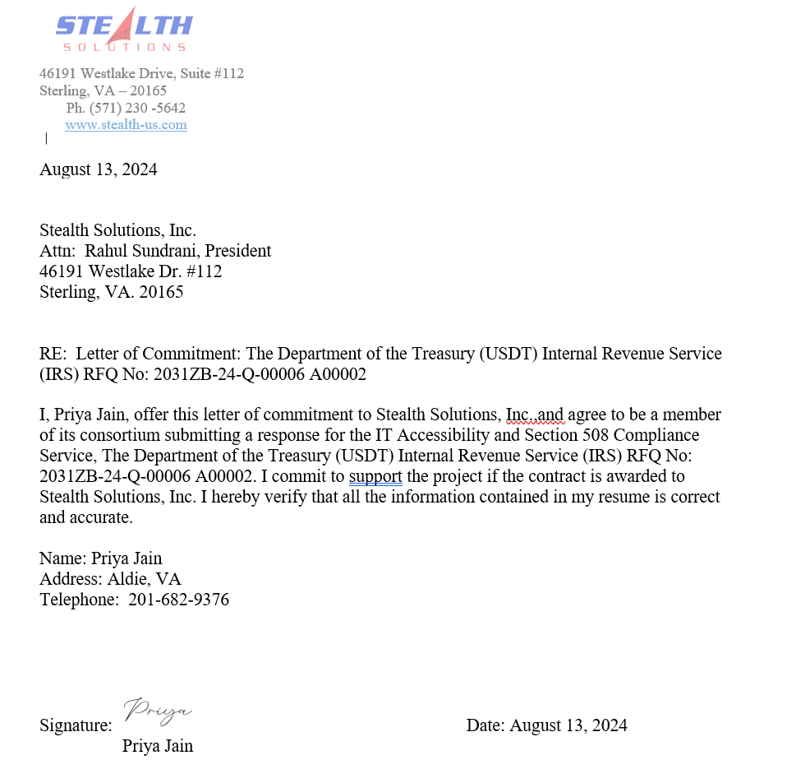

## Meena Patel

## Kyle Paciello

